**How to Create Requirements Traceability Matrix (RTM)**

### What is Traceability Matrix?(TM)

A Traceability Matrix is a document that co-relates any two-baseline documents that require a many-to-many relationship to check the completeness of the relationship.

It is used to track the requirements and to check the current project requirements are met.

### What is RTM (Requirement Traceability Matrix)?

Requirement Traceability Matrix or RTM captures all requirements proposed by the client or software development team and their traceability in a single document delivered at the conclusion of the life-cycle.

In other words, it is a document that maps and traces user requirement with test cases. The main purpose of Requirement Traceability Matrix is to see that all test cases are covered so that no functionality should miss while doing Software testing.

**Requirement Traceability Matrix – Parameters include**

* Requirement ID
* Risks
* Requirement Type and Description
* Trace to design specification
* Unit test cases
* Integration test cases
* System test cases
* User acceptance test cases
* Trace to test script

### Types of Traceability Test Matrix

* **Forward traceability**: This matrix is used to check whether the project progresses in the desired direction and for the right product. It makes sure that each requirement is applied to the product and that each requirement is tested thoroughly. It maps requirements to test cases.
* **Backward or reverse traceability:** It is used to ensure whether the current product remains on the right track. The purpose behind this type of traceability is to verify that we are not expanding the scope of the project by adding code, design elements, test or other work that is not specified in the requirements. It maps test cases to requirements.

* **Bi-directional traceability (Forward + Backward):**This traceability metrics ensures that all requirements are covered by test cases. It analyzes the impact of a change in requirements affected by the Defect in a work product and vice versa.

### How to create Requirement Traceability Matrix

Let's understand the concept of Requirement Traceability Matrix through a Guru99 banking project.

On the basis of **Business Requirement Document (BRD)** and **Technical Requirement Document (TRD)**, testers start writing test cases.

Let suppose, the following table is our Business Requirement Document or BRD for **Guru99 banking project**.

Here the scenario is that the customer should be able to login to Guru99 banking website with the correct password and user#id while manager should be able to login to the website through customer login page.

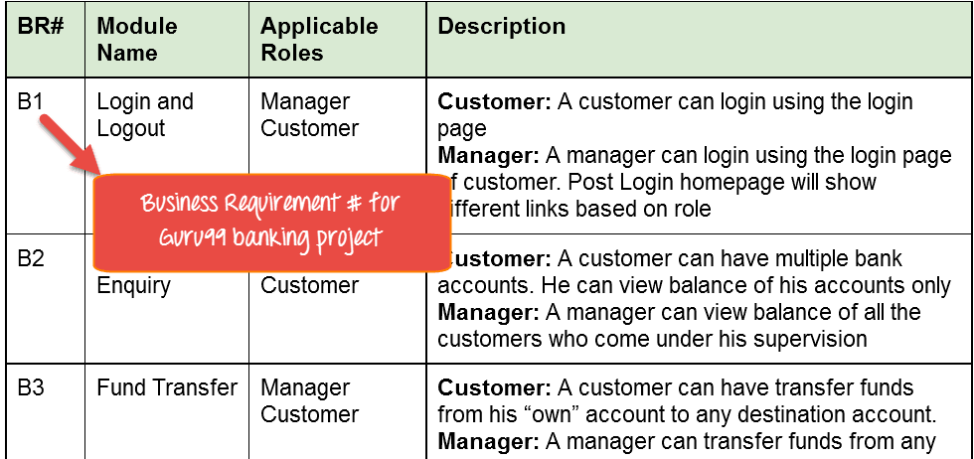

While the below table is our **Technical Requirement Document (TRD)**.

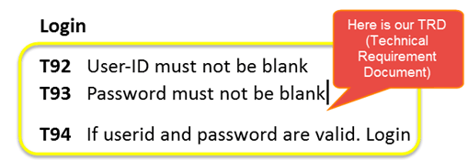

**Note:** QA teams do not document the BRD and TRD. Also some companies use **Function Requirement Documents (FRD)** which are similar **to Technical Requirement Document** but the process of creating Traceability Matrix remains the same.

Let's Go Ahead and create RTM Testing

**Step 1:**Our Test Case is

"Verify Login, when correct ID and Password is entered, it should login successfully"

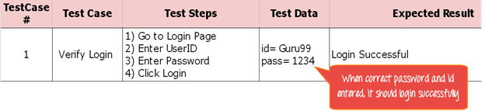

**Step 2**: Identify the Technical Requirement that this test case is verifying. For our test case, the technical requirement is T94 is being verified.

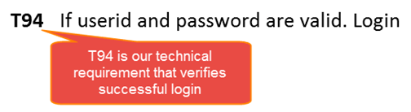

**Step 3:**Note this Technical Requirement (T94) in the Test Case.

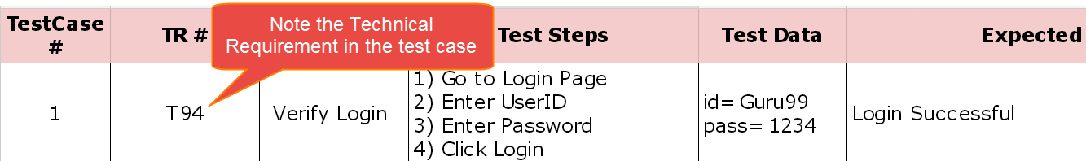

**Step 4:** Identify the Business Requirement for which this TR (Technical Requirement-T94) is defined

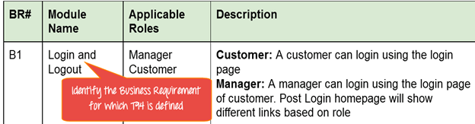

**Step 5:** Note the BR (Business Requirement) in Test Case

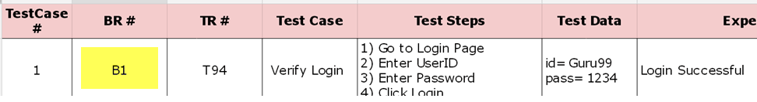

**Step 6:** Do above for all Test Cases. Later Extract the First 3 Columns from your Test Suite. RTM in testing is Ready!

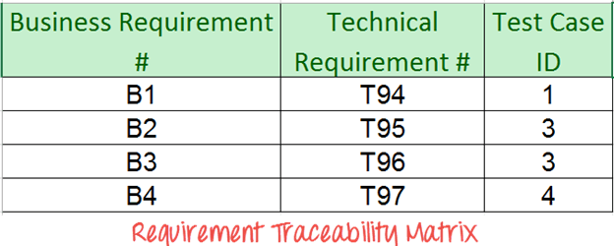

## Advantage of Requirement Traceability Matrix

* It confirms 100% test coverage
* It highlights any requirements missing or document inconsistencies
* It shows the overall defects or execution status with a focus on business requirements
* It helps in analyzing or estimating the impact on the QA team's work with respect to revisiting or re-working on the test cases